*Electrical Vehicles Market*

*By Team 1 - Nikita Itankar*

1.Types of Electric Vehicles

1.1 Battery Electric Vehicles (BEVs)

Battery electric vehicles (BEVs) are cars that are powered solely by electric motors and use rechargeable batteries as their primary source of energy. Unlike hybrid vehicles, which use a combination of gasoline and electric power, BEVs run entirely on electricity, producing zero emissions. BEVs are considered environmentally friendly and are becoming increasingly popular as the world shifts towards sustainable transportation options. They offer a clean and efficient way to travel while reducing reliance on fossil fuels.

The crown jewel of pure electric transportation, BEVs run solely on electricity from rechargeable batteries.

1.2 Plug-in Hybrid Electric Vehicles (PHEVs)

Plug-in hybrid electric vehicles (PHEVs) are cars that combine a traditional internal combustion engine with an electric motor and a rechargeable battery. PHEVs can be plugged in to charge the battery and also have the ability to run on gasoline when the battery is depleted. This dual power source allows PHEVs to offer the benefits of electric driving, such as reduced emissions and improved fuel efficiency, while also providing the flexibility of using gasoline for longer trips. PHEVs are a popular choice for consumers who want the environmental benefits of an electric vehicle without worrying about range limitations.

PHEVs combine an electric motor with a conventional engine, offering the best of both worlds: electric driving and traditional range.

1.3 Hybrid Electric Vehicles (HEVs)

Hybrid Electric Vehicles (HEVs) are vehicles that combine an internal combustion engine with an electric propulsion system. This allows the vehicle to operate using both gasoline and electricity, providing improved fuel efficiency and reduced emissions compared to traditional gasoline-powered vehicles. HEVs use regenerative braking to recharge the battery while driving, capturing energy that would otherwise be lost as heat and storing it for later use. This dual power source system allows HEVs to switch between the gasoline engine and electric motor based on driving conditions, optimizing efficiency and performance. HEVs are a popular choice for drivers looking to reduce their environmental impact without sacrificing the convenience and range of a gasoline-powered vehicle.

2.Market Segmentation by Vehicle Size

2.1 Compact EVs

Compact electric vehicles (EVs) are smaller-sized electric cars that are designed for urban driving and short commutes. These vehicles are typically more affordable and have a smaller footprint compared to traditional cars, making them ideal for navigating crowded city streets and parking in tight spaces. Compact EVs are known for their energy efficiency and low operating costs, as they rely on electric power instead of gasoline. While they may have limited range compared to larger EVs, compact EVs are a practical and eco-friendly transportation option for city dwellers looking to reduce their carbon footprint.

Effortlessly navigate urban landscapes with compact EVs. Their small size makes them ideal for zipping through crowded streets.

2.2 Midsize EVs

Midsize electric vehicles (EVs) are larger than compact EVs but smaller than full-size EVs, offering a balance between interior space and driving range. These vehicles are designed to comfortably accommodate passengers and cargo while still providing the benefits of electric power, such as reduced emissions and lower operating costs. Midsize EVs are a popular choice for drivers who need a bit more space and range than compact EVs can offer, making them versatile options for everyday driving and longer trips. With advancements in battery technology, midsize EVs are becoming increasingly competitive with traditional gasoline-powered vehicles in terms of performance and convenience.

Experience the perfect balance of comfort and efficiency with midsize EVs. They offer ample space for passengers and cargo.

2.3 Full-size EVs

Full-size electric vehicles (EVs) are larger, spacious vehicles that offer ample seating and cargo capacity, making them suitable for families or individuals who require more room for passengers and belongings. These EVs typically have longer driving ranges and more advanced features compared to compact or midsize EVs, providing a luxurious and comfortable driving experience. Full-size EVs are often equipped with cutting-edge technology, such as advanced driver-assistance systems and high-quality infotainment systems, making them a top choice for those looking for a premium electric vehicle option. While full-size EVs may come at a higher price point, they offer a combination of performance, comfort, and sustainability that appeals to many drivers seeking a high-end electric driving experience. Embrace luxury and spaciousness with full-size EVs. These vehicles redefine comfort and make a bold statement on the road.

**3. Market Segmentation by Range**

* Short-range EVs :

Perfect for daily commutes and urban adventures, short-range EVs typically offer range between 80 and 120 miles.

* Medium-range EVs :

Strike a balance between urban efficiency and longer trips with medium-range EVs, boasting a range of 120 to 250 miles.

* Long-range EVs :

Unleash your wanderlust with long-range EVs. These remarkable vehicles can cover distances exceeding 250 miles on a single charge.

**4. Market Segmentation by Price Range**

4.1 Affordable EVs:

Affordable electric vehicles (EVs) are those that are priced competitively compared to traditional gasoline-powered vehicles. These EVs typically have lower upfront costs, reduced maintenance expenses, and may also qualify for government incentives or rebates. By offering a cost-effective alternative to traditional vehicles, affordable EVs make sustainable transportation more accessible to a wider range of consumers.

Embrace sustainability without breaking the bank. Affordable EVs democratize

mobility and make it accessible to all.

4.2 Mid-range EVs:

Mid-range electric vehicles (EVs) typically offer a balance between price, range, and features. These EVs may have a slightly higher price point than entry-level models but often come with improved battery range, performance capabilities, and additional technology features. Mid-range EVs appeal to consumers looking for a good balance of affordability and functionality, making them a popular choice in the electric vehicle market.

4.2 Luxury EVs:

Luxury electric vehicles (EVs) are high-end electric cars that offer premium features, cutting-edge technology, luxurious interiors, and top-notch performance. These EVs are designed to provide a luxurious driving experience while also being environmentally friendly. Luxury EVs often come with advanced safety features, high-quality materials, and innovative design elements, making them a popular choice for consumers who prioritize luxury and sustainability.

Some of the data is collected from Indian government sites regarding EV market in India.

Here are some valuable insides from dataset

This barplot shows which brand has the best efficiency

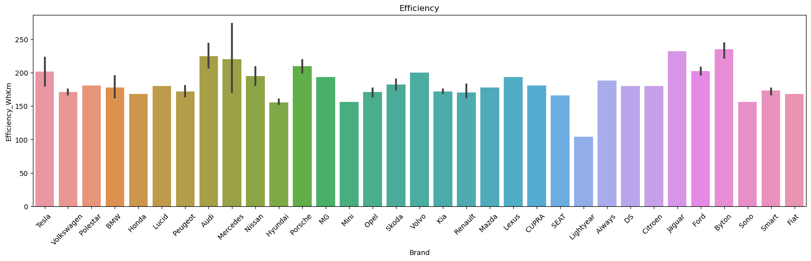

**Analysis of Charging Station**

To run this electrical vehicle market smoothly there must be easy availability of charging station in each state. For doing analysis of charging stations we will take a reference from a Indian government sites so that we can have the better idea in which state we can focus more or in which area we have the better opportunity to start up the things accordingly.

**Operational Electric Vehicle (EV) charging station by State/UT:**

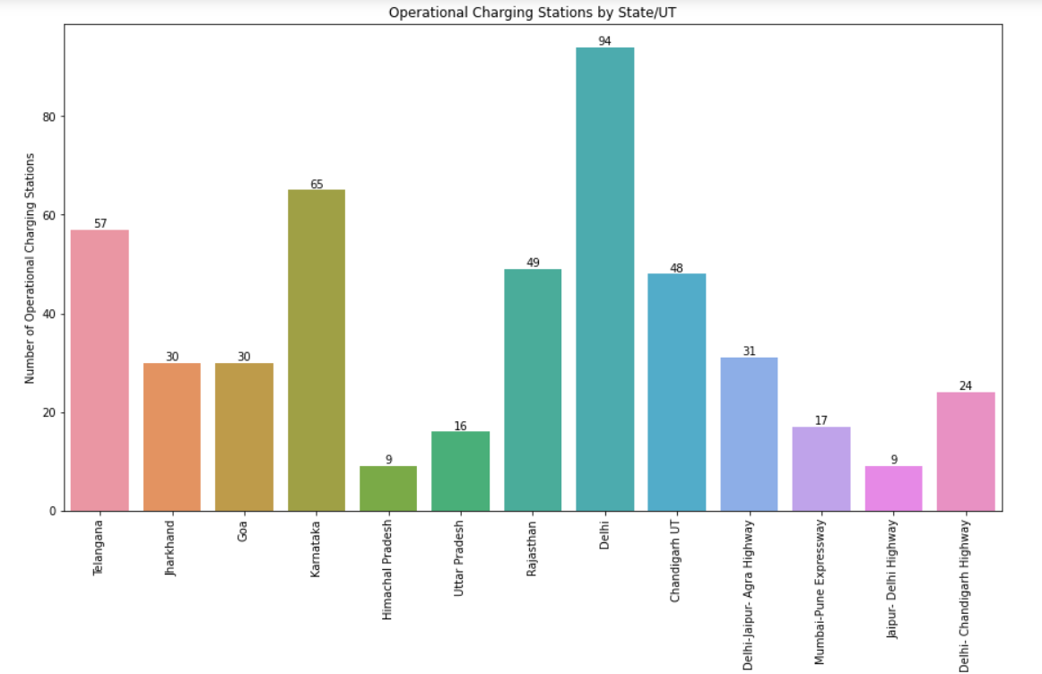

Fig: Operating charging stations by State/UT

Here are the valuable insights from the data sets:

* Delhi has the highest number of operational charging stations with 94, followed by Telangana with 57 and Rajasthan with 49.
* The states of Goa, Jharkhand, and Delhi-Jaipur-Agra Highway have an equal number of operational charging stations, each with 30.
* Himachal Pradesh and Jaipur-Delhi Highway have the lowest number of operational charging stations, both with only 9.
* Mumbai-Pune Expressway and Uttar Pradesh have relatively fewer operational charging stations, with 17 and 16 respectively.
* Telangana, Karnataka, and Rajasthan have a relatively higher number of
* operational charging stations compared to other states.
* Delhi, being the capital city, has a significant number of operational charging stations, which indicates the growing adoption of electric vehicles in the region.
* The number of operational charging stations varies across different states and highways, suggesting differences in infrastructure development and government initiatives for electric vehicle adoption.

**Electric Vehicle (EV) chargers sanctioned by State/UT:**

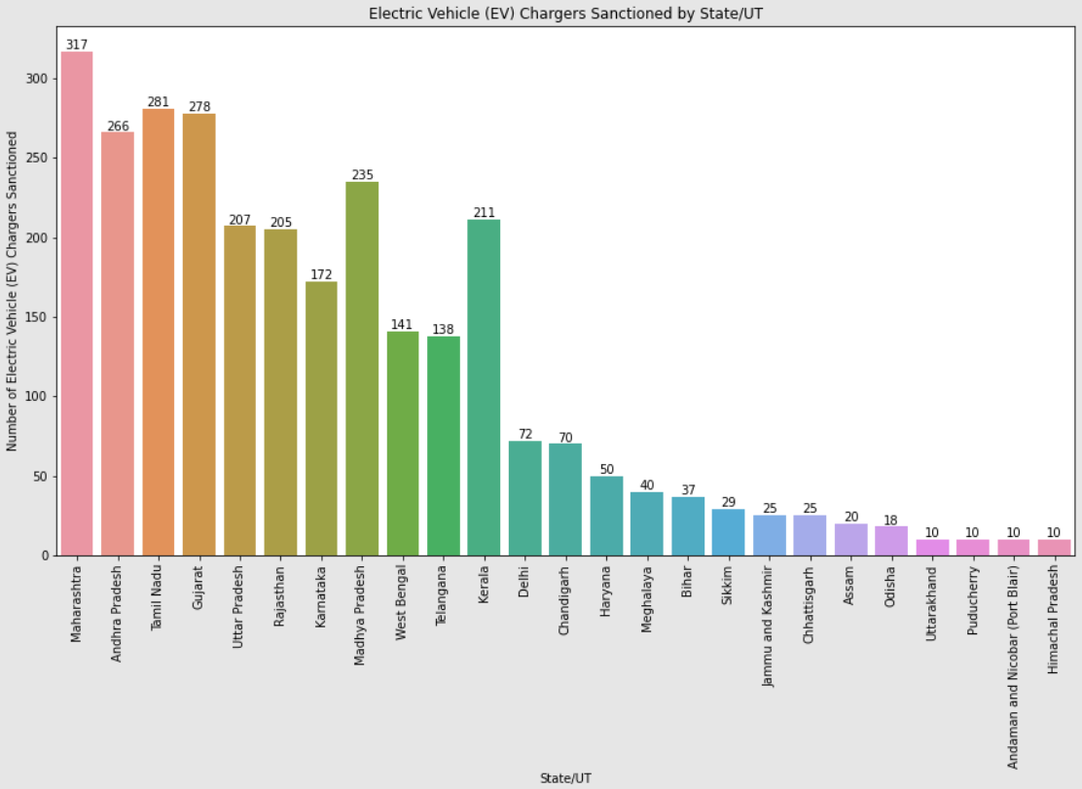

Fig: Electric vehicle (EV) chargers sanctioned by State/UT

Based on the provided data of the number of Electric Vehicle (EV) chargers sanctioned by State/UT, here are some valuable insights:

* Maharashtra has the highest number of EV chargers sanctioned with 317, followed by Tamil Nadu with 281 and Gujarat with 278.
* Andhra Pradesh, Madhya Pradesh, and Kerala also have a significant number of EV chargers sanctioned, each with over 200 chargers.
* States like Jammu and Kashmir, Chhattisgarh, Assam, Odisha, and Bihar have a relatively lower number of sanctioned EV chargers, ranging from 18 to 37.
* Delhi, despite being the national capital, has a relatively lower number of sanctioned EV chargers with 72, indicating potential for further infrastructure development in the city.
* The distribution of sanctioned EV chargers varies across states, reflecting differences in government initiatives, policies, and the level of electric vehicle adoption.
* Maharashtra, Andhra Pradesh, Tamil Nadu, and Gujarat emerge as the leading states in terms of sanctioned EV chargers, indicating a proactive approach towards promoting electric vehicle infrastructure.

These insights provide a general overview of the distribution of sanctioned EV chargers among the mentioned states/UT. Further analysis could involve comparing these numbers with factors such as population, electric vehicle sales, or government incentives to gain a more comprehensive understanding of the electric vehicle charging infrastructure landscape.

**Electric Vehicle (EV) sales/invoice by State/UT:**

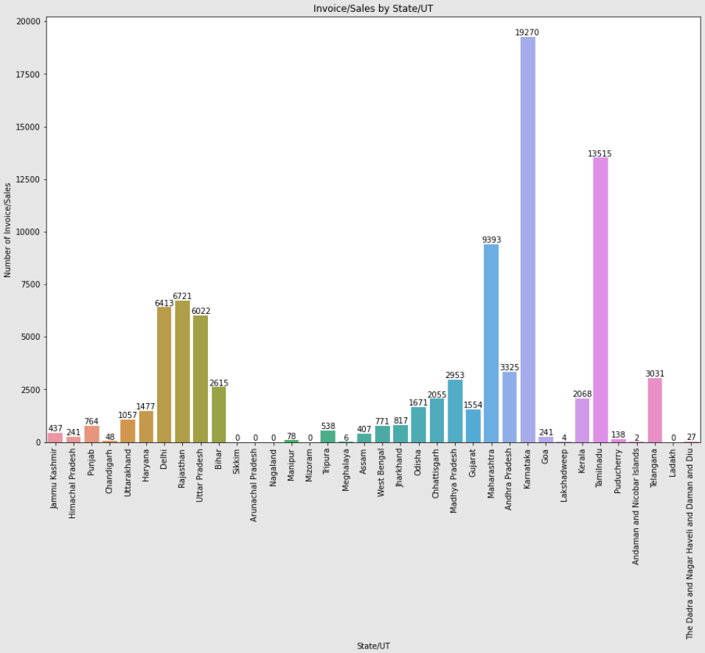

Fig: Electric vehicle (EV) sales/invoice by State/UT

Based on the provided data of the number of invoice/sales by State/UT, here are some valuable insights:

* Karnataka has the highest number of invoice/sales with 19,270, followed by Tamil Nadu with 13,515 and Maharashtra with 9,393.
* Uttar Pradesh, Rajasthan, and Delhi also have a significant number of invoice/sales, each with over 6,000.
* States like Bihar, Madhya Pradesh, and Chhattisgarh have moderate numbers of invoice/sales, ranging from 2,615 to 2,953.
* Sikkim, Arunachal Pradesh, Nagaland, Mizoram, and Ladakh have no reported invoice/sales in the provided data.
* Kerala, Odisha, and Telangana have a relatively higher number of invoice/sales, ranging from 1,671 to 3,031.
* The distribution of invoice/sales varies across different states/UT, indicating differences in economic activity and market demand.
* Karnataka, Tamil Nadu, and Maharashtra emerge as the leading states in terms of invoice/sales, indicating robust business and commercial activity.

Conclusion

As the electric vehicle industry continues to advance, understanding the

various elements of market segmentation is crucial. By decoding the complexities and nuances, consumers can make informed decisions and

embark on an electrifying journey that aligns with their unique needs and

preferences.